
North South University
Department of Electrical & Computer Engineering

Lab Report

Experiment No: | 6
Experiment Title: | Building a Single Cycle Data path

Course Code: | CSE332L
Course Name: | Computer Organization & Architecture Lab

Name & ID: | Md. Rifat Ahmed ~ 1931725042

Date of Experiment: | 7/12/2021
Date of Submission: | 8/12/2021

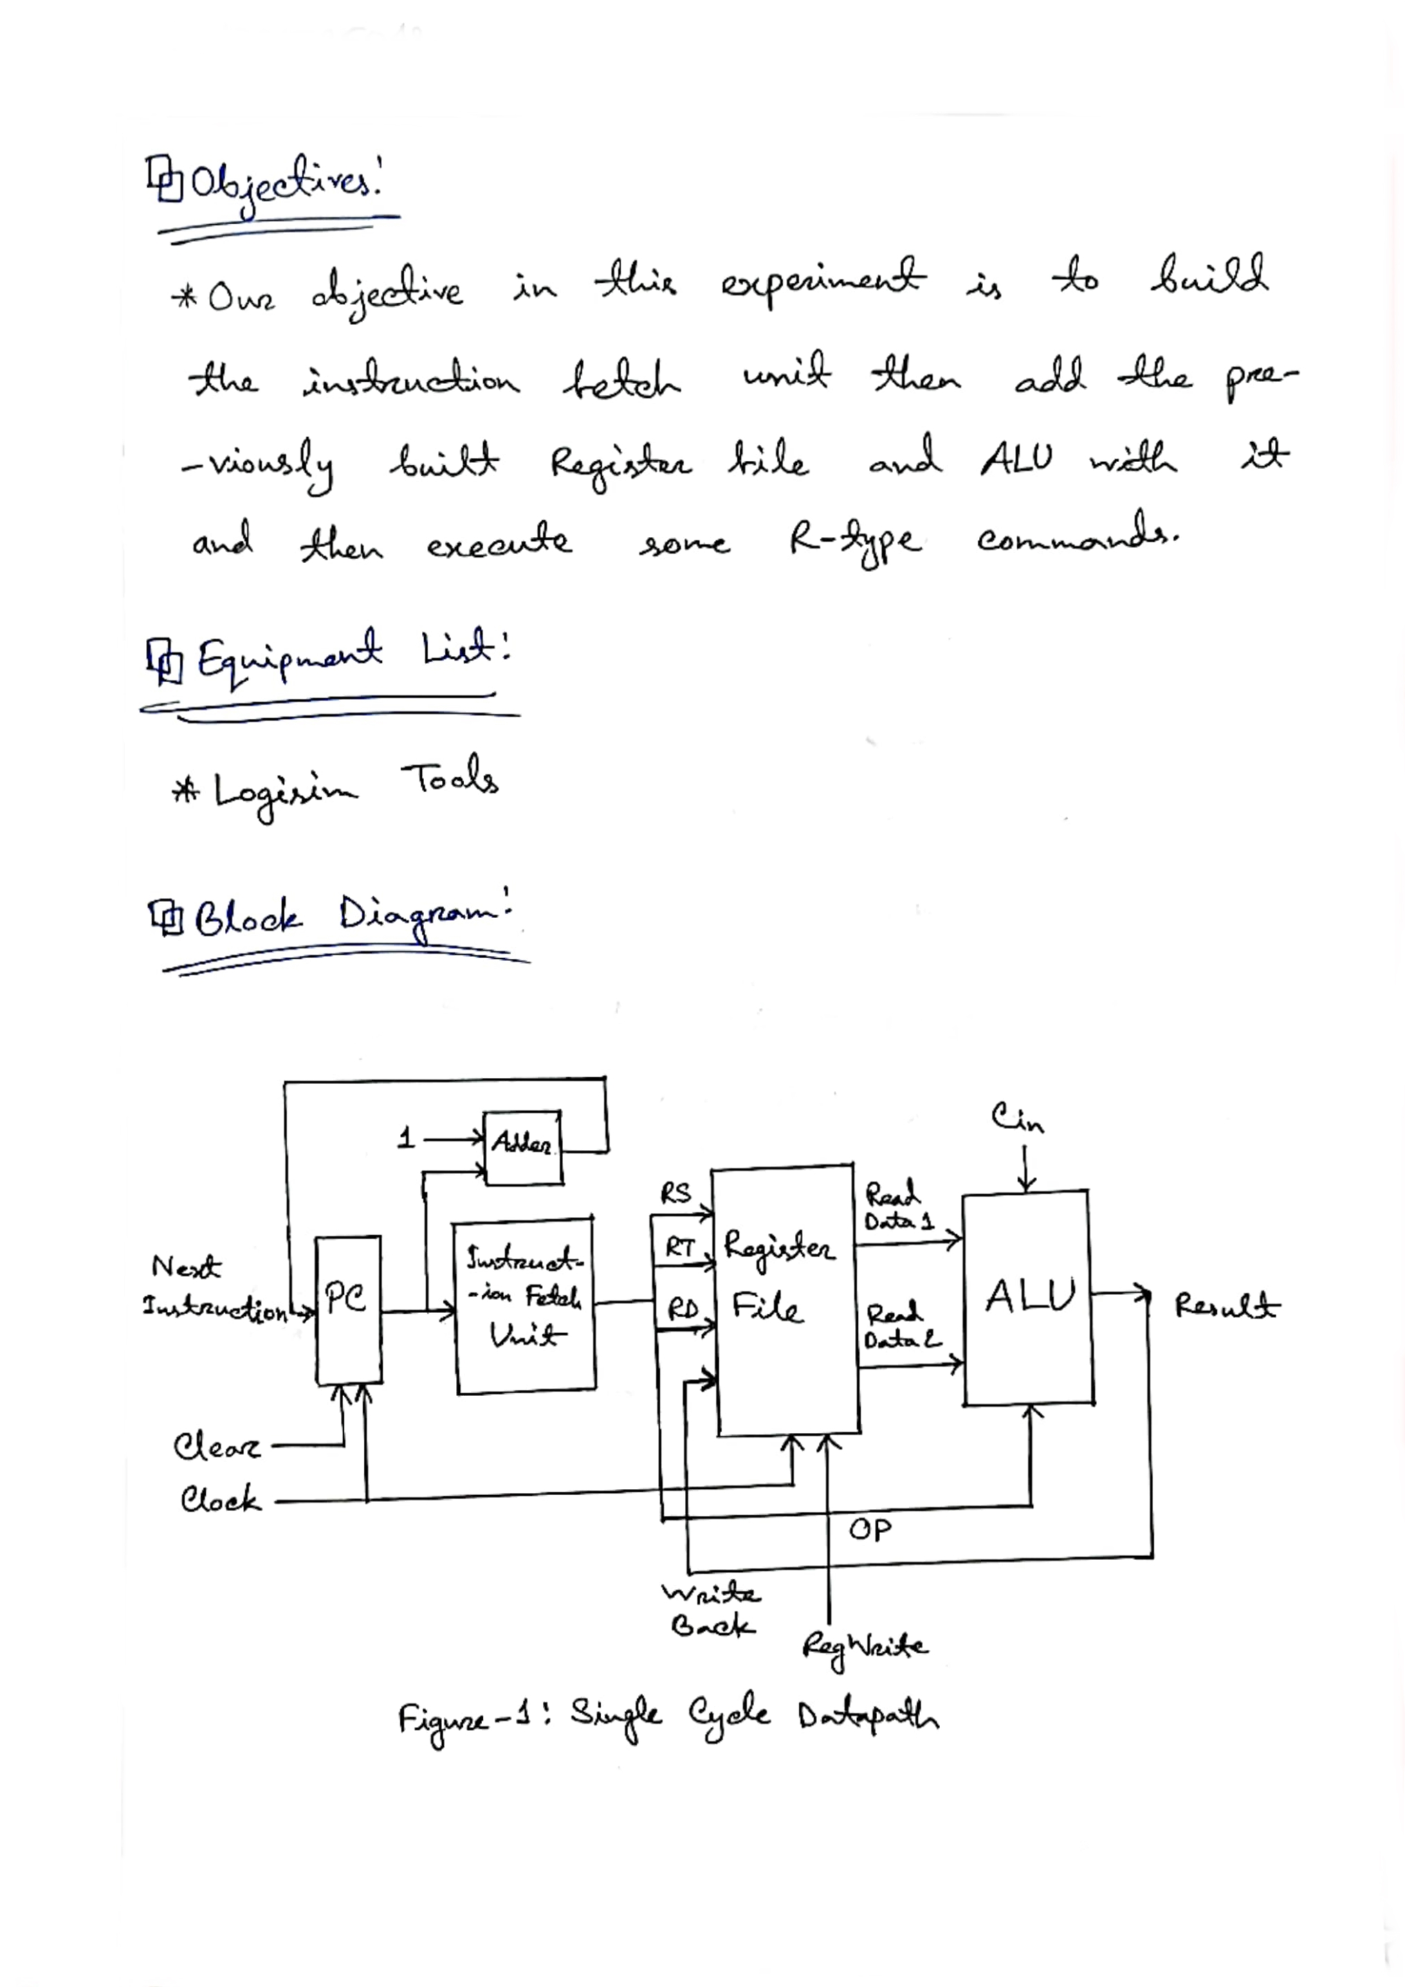
Tables:

Our Register file is of 16-bit ISA with the following fields where the formats of the R-type instruction are:

OP (4-bit) | Rs (4-bit) | Rt (4-bit) | Rd (4-bit)

Register Table:

Register Serial | Register No.  (In Binary) | Register Name
$0 | 0000 | $zero
$1 | 0001 | $at
$2 | 0010 | $v0
$3 | 0011 | $a0
$4 | 0100 | $a1
$5 | 0101 | $t0
$6 | 0110 | $t1
$7 | 0111 | $t2
$8 | 1000 | $t3
$9 | 1001 | $s0
$10 | 1010 | $s1
$11 | 1011 | $s2
$12 | 1100 | $s3
$13 | 1101 | $k0
$14 | 1110 | $gp
$15 | 1111 | $ra

OP Code Table:

S1 | S0 | Cin | Microopertion
0 | 0 | 0 | Add
0 | 0 | 1 | Add with Carry
0 | 1 | 0 | Subtract with Borrow
0 | 1 | 1 | Subtract
1 | 0 | 0 | Transfer A  A1 A0 + 0 0 + 0 = Transfer A
1 | 0 | 1 | Increment A  A1 A0 + 0 0 + 1 = Increment A
1 | 1 | 0 | Decrement A  A1 A0 + 1 1 + 0 = Decrement A
1 | 1 | 1 | Transfer A  A1 A0 + 1 1 + 1 = Transfer A

Circuit Diagrams:

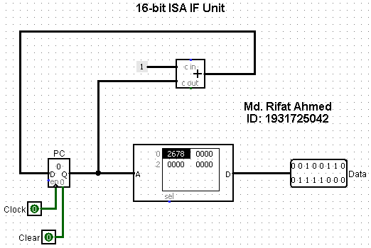

Figure – 2: 16-bit ISA Instruction Fetch (IF) Unit

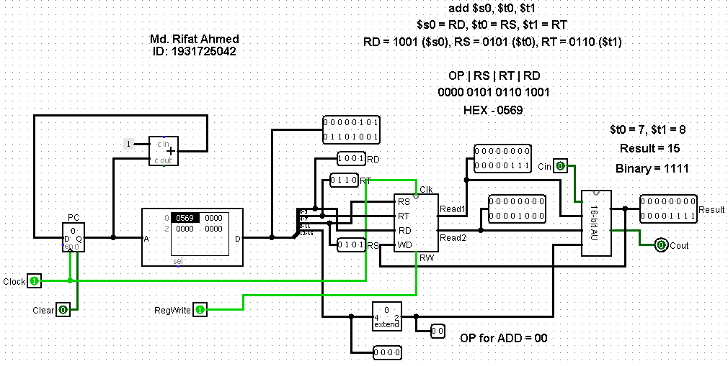

Figure – 3: IF, ID, ExE for add $s0, $t0, $t1 where $t0 = 7 & $t1 = 8

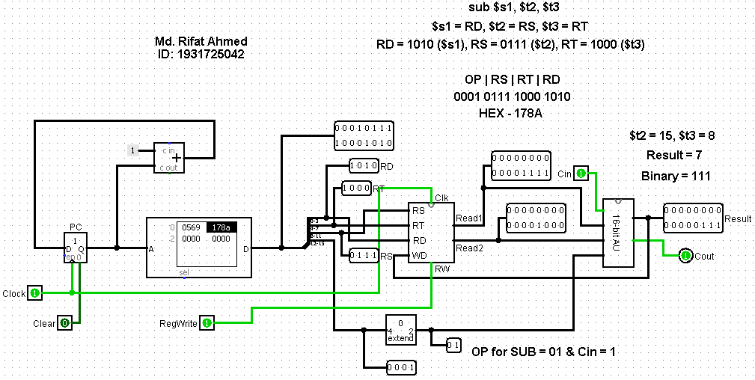

Figure – 4: IF, ID, ExE for sub $s1, $t2, $t3 where $t2 = 15 & $t3 = 8

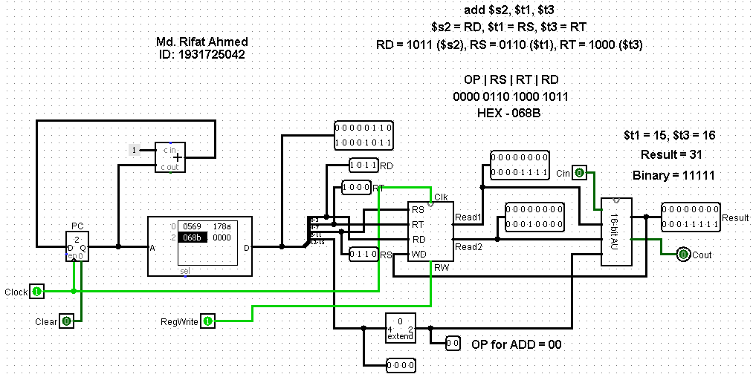
Figure – 5: IF, ID, ExE for add $s2, $t1, $t3 where $t1 = 15 & $t3 = 16
